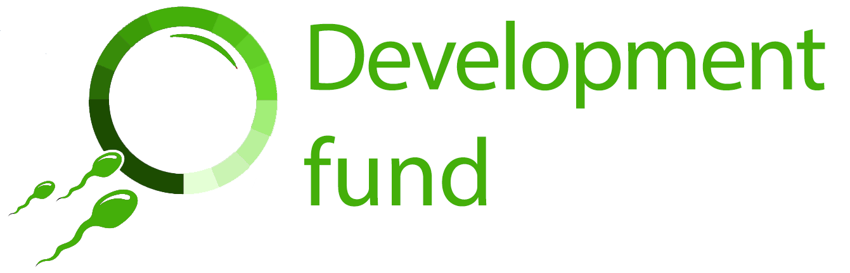

Cambridge Reproduction SRI: Development Fund application form (2021)

Before applying, please refer to the separate guidance notes, which can be downloaded from the Cambridge Reproduction SRI website (www.repro.cam.ac.uk/development-fund). If you have any questions about the application, please contact Christina Rozeik (coordinator@repro.cam.ac.uk).

Applicant details
Full name
Role/position
Department
Email
Telephone

Please give a brief summary of your current research interests:

Are you currently a member of Cambridge Reproduction SRI?
Yes / No please delete as applicable

If you would like to join Cambridge Reproduction SRI, please fill in and return the application form on our website. Membership is free, and is open to all current staff and students at the University of Cambridge and affiliated institutions who have a research interest in reproduction.

Details of proposed activity
Date(s) of activity
Brief description of the activity (e.g. conference, workshop), including name and location
Links to any relevant information (e.g. conference website)

How will this activity benefit your current and future work in the area of reproduction?

How will you share the knowledge or skills gained with other people?

Total cost of the activity (please include a breakdown of costs)
Conference/course fee
Travel
Accommodation
Meals/subsistence
Other relevant costs (please detail)
Total activity cost

Amount applied for (maximum £500)

Do you have other sources of funding available (e.g. self-funding, other grants)? If so, please give details below

Have you received a grant from Cambridge Reproduction SRI previously?
Yes / No please delete as applicable

If you answered yes, please give details

Supporting information
Applications must be accompanied by a letter of support from your supervisor, line manager or head of department and a recent 2-page CV.

Have you enclosed a letter of support (details below)?
Yes / No please delete as applicable

Have you enclosed a recent 2-page CV?
Yes / No please delete as applicable

Please make sure that your application form has been signed and dated:
Signed
Date

In signing this application I confirm that the information that I have given is accurate and that I accept the terms and conditions, listed below, which would apply to any grant that may be awarded to me.

Please return completed forms to Christina Rozeik (coordinator@repro.cam.ac.uk) by the deadline shown on our website: www.repro.cam.ac.uk/development-fund. If you have any questions about the application process or about the Development Fund, please contact Christina Rozeik as above.

Development Fund terms and conditions
1. If you are awarded a grant you will be required to:
i) acknowledge our support in any outcomes from your training/development activity;
ii) write a short report on the funded activity, using the post-award report form on our website. Your report should be accompanied by at least one image of your funded activity, which we will use on the Reproduction SRI website (www.repro.cam.ac.uk) together with a summary based on the text from your report.
iii) provide receipts giving proof of expenditure. We can only reimburse expenses relating to your award if they are accompanied by receipts or other proof of expenditure.
2. We will only pay your grant to you once we have received your report and receipts.
3. We would be very glad to receive any additional images of your funded activity. Please also provide a caption and credit line for each image. By supplying images you are agreeing that Cambridge Reproduction SRI may use these on its website, social media or in its published annual report.
4. Applications must be accompanied by a letter of support from your supervisor, line manager or head of department.

