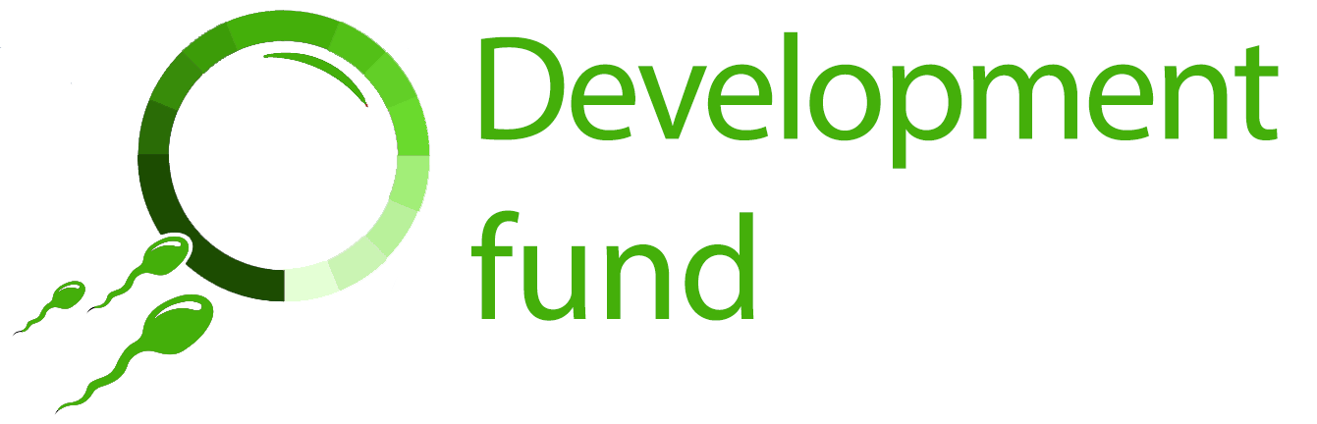

Cambridge Reproduction: Development Fund Post-Award Report Form (2023–24)

Please return this report form to Christina Rozeik (coordinator@repro.cam.ac.uk) within one month of completing your funded training or development activity.
We will use some of this information on our website, to show the kinds of activities that we have previously supported through the Development Fund.

Applicant and award details
Full name
Role/position
Department
Email
Activity funded
Date of award
Amount of award

Final costs
Total final cost of the activity (please include a breakdown of expenses). You will need to include receipts or proof of expenditure for any expenses that are covered by your award.
Expense | Amount | Receipt?
Conference/course fee
Travel
Accommodation
Meals/subsistence
Other relevant costs (please detail)
Total final activity cost

Post-activity report
What was the training or development activity that we funded? What activities were involved, and what have you learned from it? Why did you choose to undertake it?

How has this activity benefited your current and future work in the area of reproduction?

How will you share the knowledge or skills gained with other people?

Supporting information
Reports must be accompanied by receipts or proof of expenditure for any costs that are covered by the award.

Have you enclosed proof of expenditure for the costs that your award covers?
Yes / No please delete as applicable

Have you attached an image(s) of your activity for use on the Cambridge Reproduction website?
Yes / No please delete as applicable

Please give details of any captions or credits that should accompany the image(s):

Please make sure that your application form has been signed and dated:
Signed
Date

In signing this application I confirm that the information that I have given is accurate and that I give permission to Cambridge Reproduction to use text from this report and/or the images supplied on its website, social media or annual report.

Please return completed forms to Christina Rozeik (coordinator@repro.cam.ac.uk) within one month of completing your funded activity. If you have any questions about the reporting process or about the Development Fund, please contact Christina Rozeik as above.

